**Docker Task**

**Task Description:**

Install docker on EC2 and explore the docker commands (docker images, containers, volumes, network)

**Step 1: Launch an EC2 Instance**

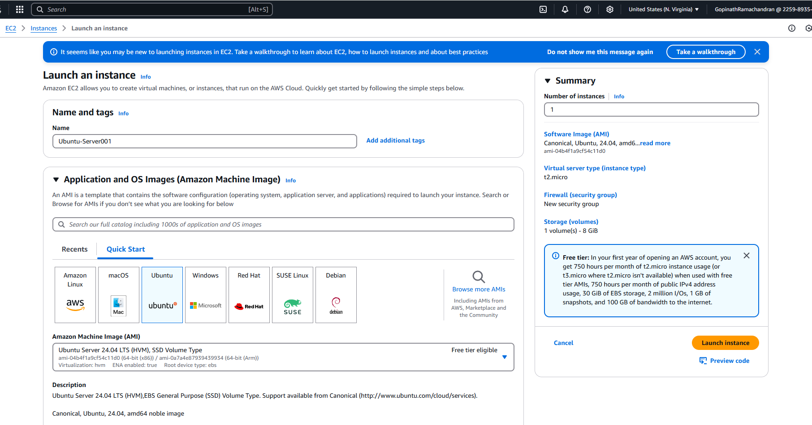

Step 2: Connect to the EC2 Instance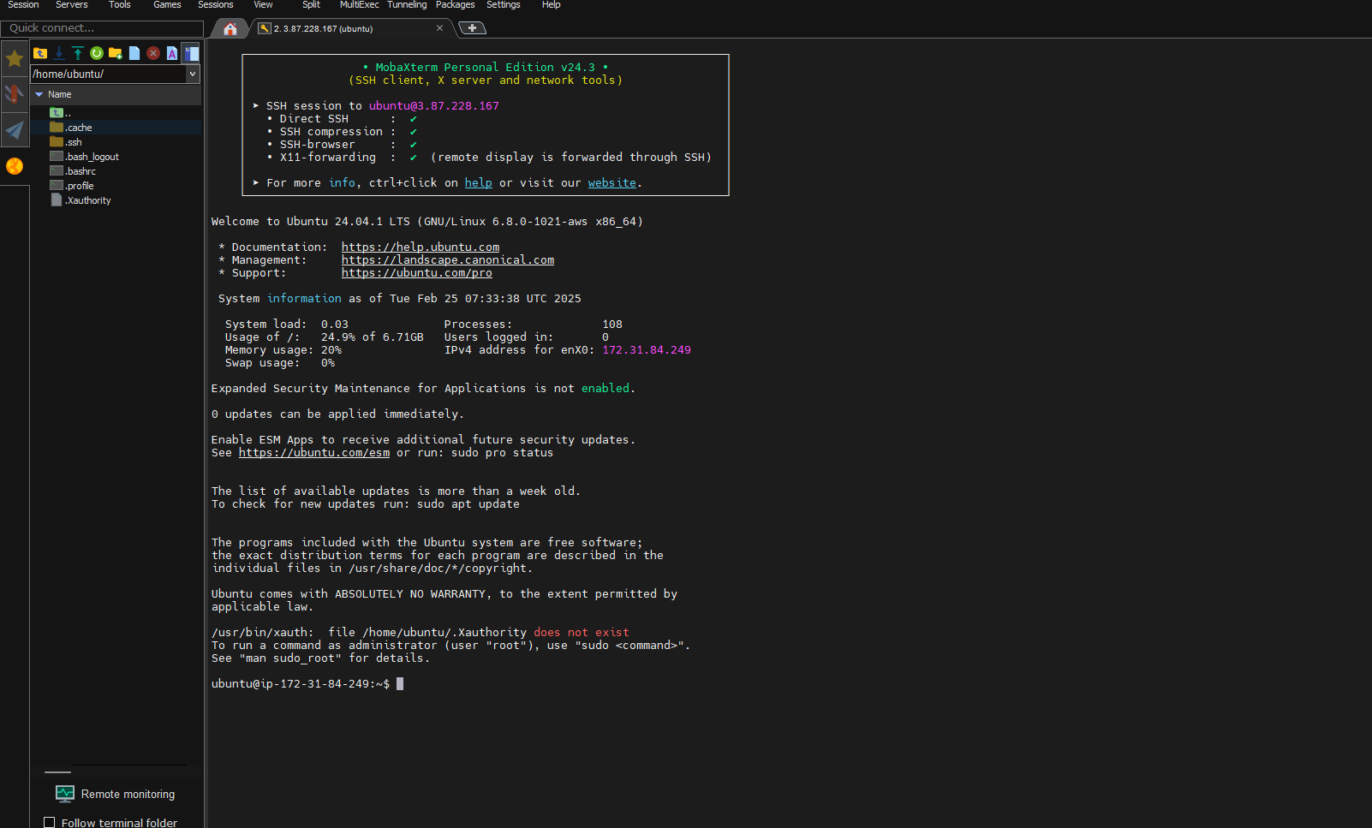

Step 3: Install Docker and Start and Enable Docker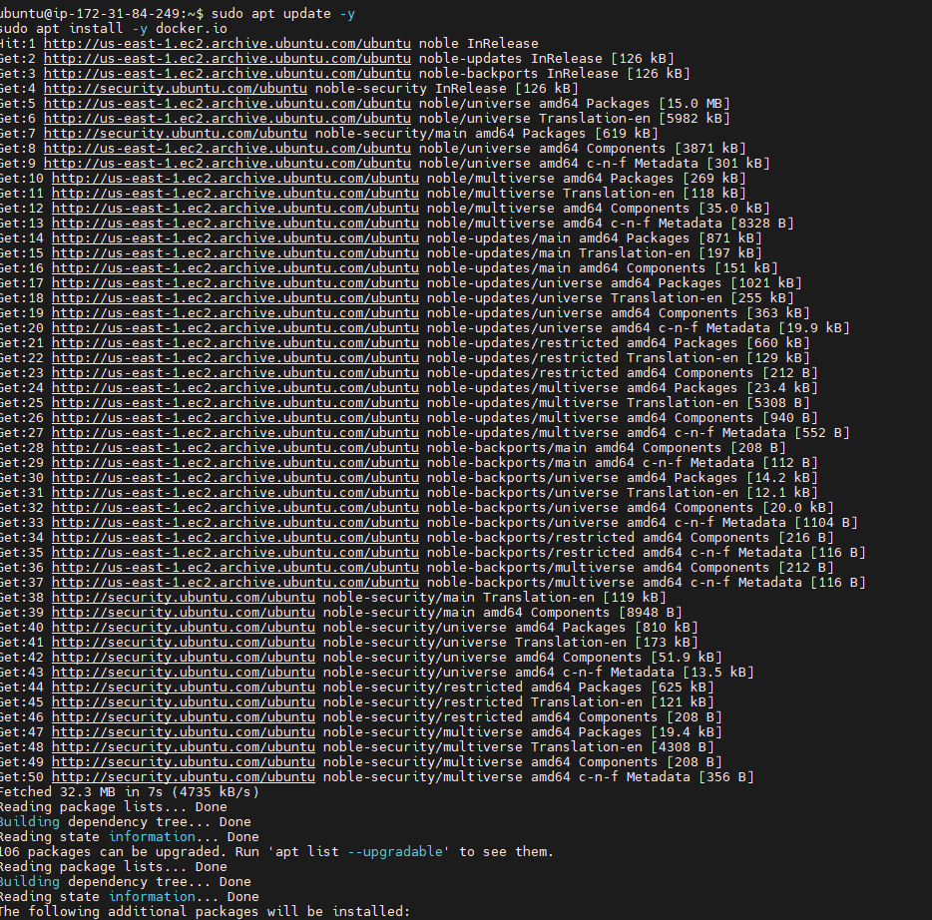

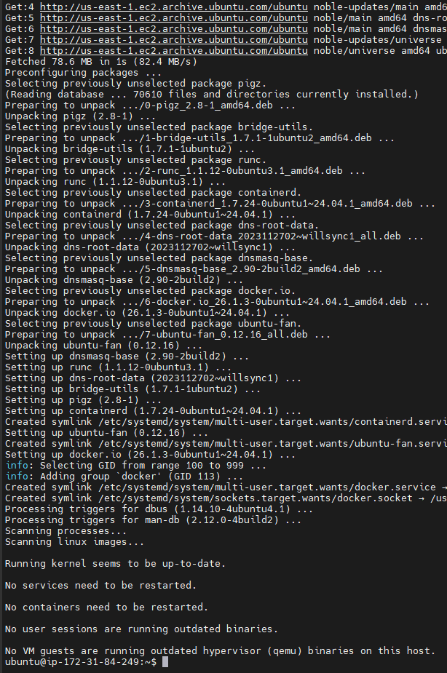 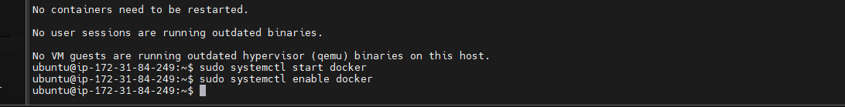

Step 4: Add User to Docker Group and Check Docker Version

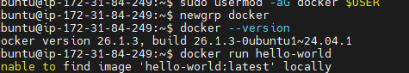

Exploring Docker Commands

1. Check Docker Version
2. List Docker Images
3. .Pull a Docker Image
4. List Running Containers
5. List All Containers
6. Run a Container

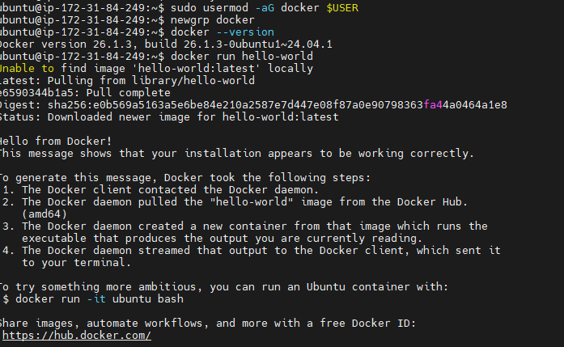

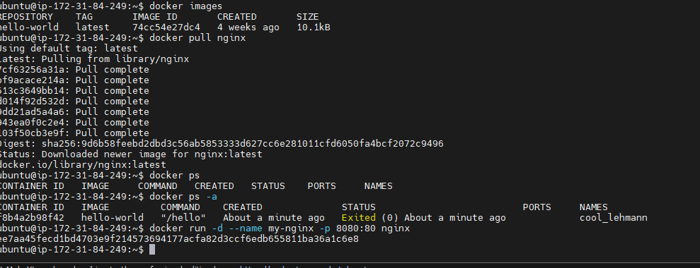

Exploring Docker Volumes

1. Create a Volume
2. List Volumes
3. Inspect a Volume
4. Use a Volume in a Container

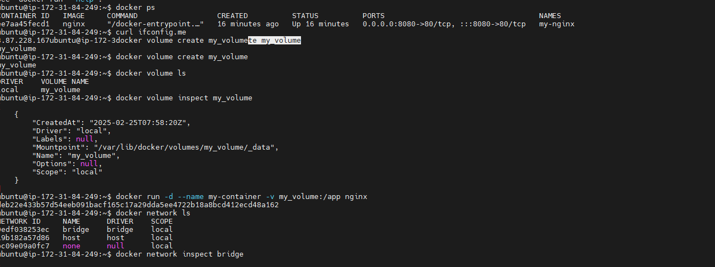

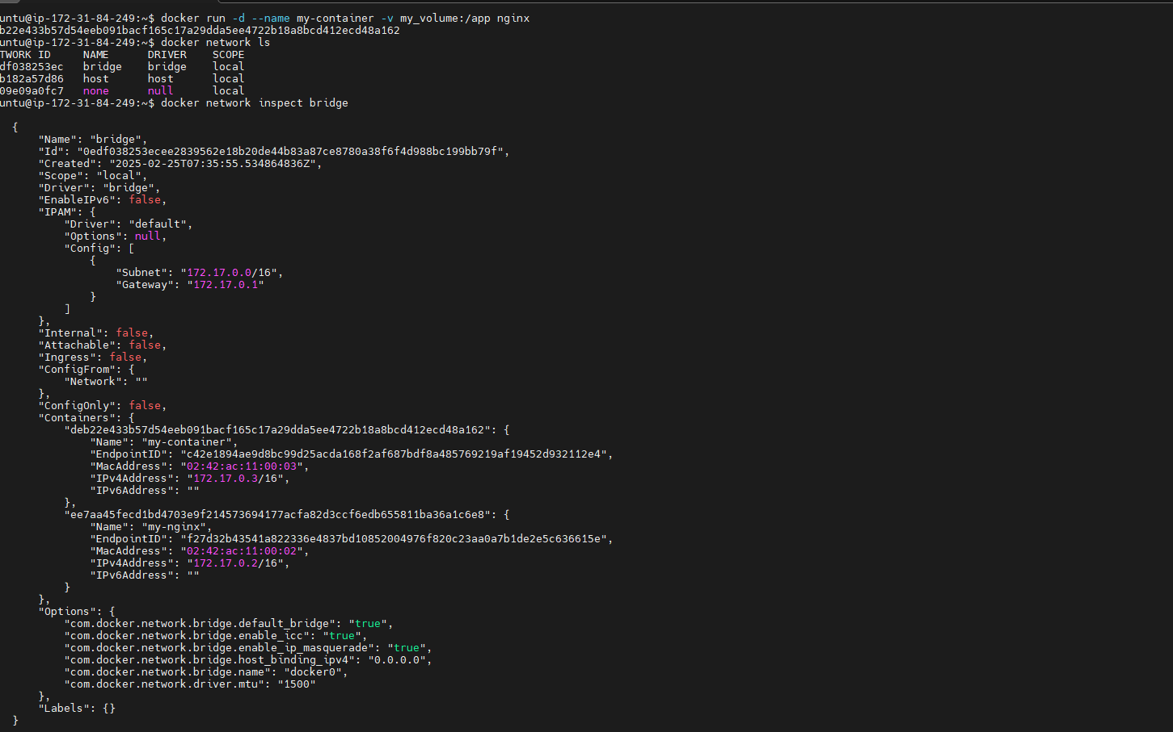

Exploring Docker Networks

1. List Networks

2. Inspect a Network

3. Create a Custom Network

4. Run a Container in a Custom Network

